Job Analytics Tool
(CLI-Based Data Analysis System)

-: By :-
Dhananjay Bilade

OverView

The Job Analytics Tool is a command-line based Python application designed to analyze job listing datasets and generate meaningful insights using data analysis and visualization techniques.

This project focuses on real-world data processing workflows, including:
- Data cleaning:
- Remove duplicate records
- Format salary columns into numerical values
- Create new features such as:
- Salary category
- Job posting month
- Experience level

- Feature engineering:
- Filter jobs based on:
- Category
- Location
- Salary range
- Analyze dataset to find:
- Jobs per category
- Jobs per location
- Average salary per category

- Statistical analysis:
- Use NumPy to calculate:
- Mean salary
- Median salary
- Standard deviation
- Salary percentiles
- Compare salary trends across locations and job categories

- Visualization:
- Create charts using Matplotlib / Seaborn
- Bar chart – Jobs by category
- Bar chart – Jobs by location
- Histogram chart – Salary Distribution
- Pie chart – Jobs Category
- Reg chart – Experience vs Salary
- Line chart – Job postings over time

Objective :
✔ Dataset loading and preprocessing
✔ Data cleaning (missing values, duplicates)
✔ Job filtering (category, location, salary)
✔ Statistical analysis (mean, median, std deviation)
✔ Data visualization (charts using Matplotlib & Seaborn)
✔ CLI menu-based interaction
✔ Export results to CSV/Excel

Project WorkFlow:

Technology Stack

The technology stack for the Job Analytics Tool is designed to handle the entire data pipeline, from raw ingestion to professional reporting. Each library has been selected for its specific role in data science and software development.

1. Programming Language
- Python: Chosen as the primary language for its extensive ecosystem of data libraries and readability.

2. Data Manipulation & Numerical Computation
- Pandas: Used for loading datasets via read_csv() or read_excel(), inspecting data with head() and describe(), and handling missing values with fillna() or dropna().
- NumPy: Employed for high-performance mathematical operations to calculate the mean, median, standard deviation, and salary percentiles.

3. Data Visualization
- Matplotlib: Utilized as the foundation for creating bar charts, line graphs, and pie charts, as well as saving visual outputs using plt.savefig().
- Seaborn: Integrated for advanced statistical visualizations to create more aesthetically pleasing and complex charts.

4. Data Storage & Formats
- CSV (Comma Separated Values): The primary format for importing raw job listings and exporting cleaned datasets.
- Excel (.xlsx): Supported for data input and generating final summary reports.

5. Development & Interface
- CLI (Command-Line Interface): The tool is built as a menu-driven terminal application, allowing users to select tasks like "Filter jobs" or "Perform statistical analysis" through a numbered menu.
- Modular Architecture: The project is structured into separate Python scripts for preprocessing, analysis, visualization, and documentation to ensure code maintainability.

Summary Table of Technologies
Category | Technology | Purpose
Core | Python | Main logic and application flow.
Data Handling | Pandas | Cleaning, filtering, and feature engineering.
Statistics | NumPy | Mathematical analysis and trends.
Visuals | Matplotlib/Seaborn | Generating job trend charts.
Output | CSV/Excel | Exporting results and reports.

Code Structure

Module Explanation
#main.py
- Handles CLI menu
- Calls functions from other modules
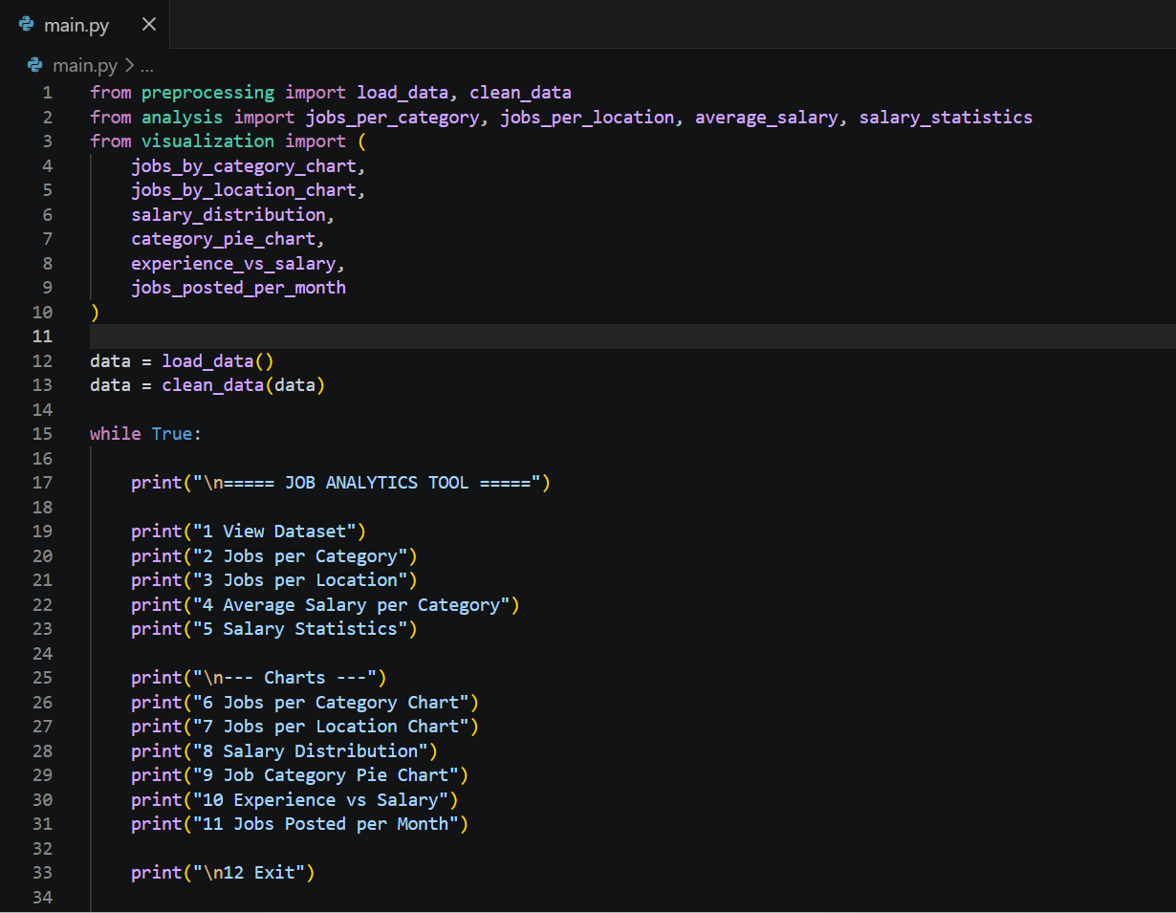
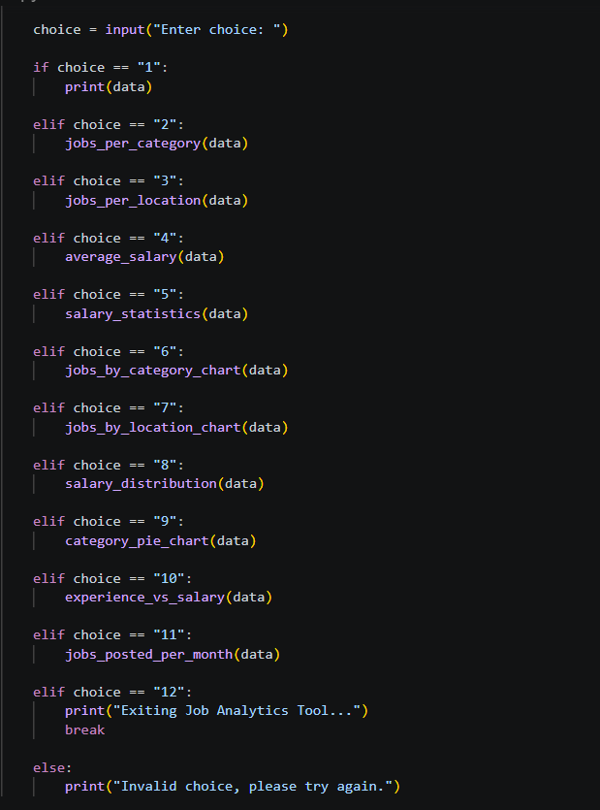

#preprocessing.py
- Load dataset, Handle missing values, Convert columns (salary, date), Feature engineering

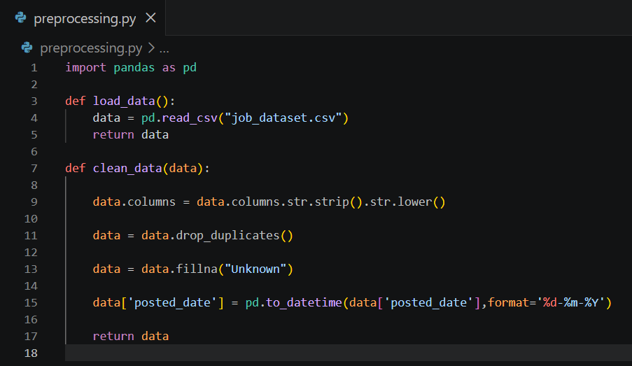
#analysis.py
- Mean salary, Median salary, Standard deviation, etc.
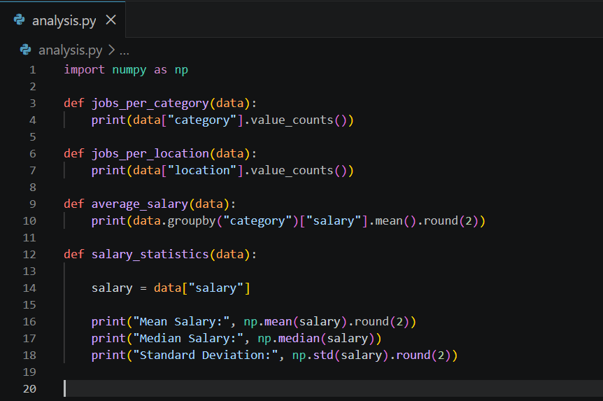

#visualization.py
- Bar charts (Jobs By Category)
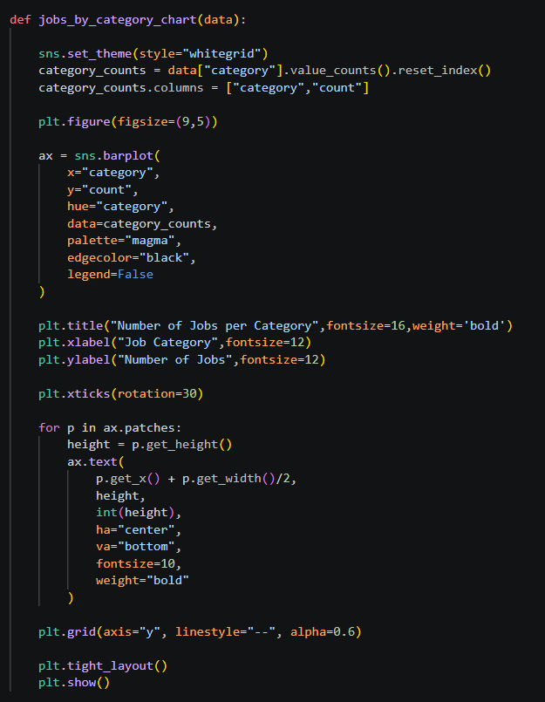
- Bar charts (Jobs By Location)
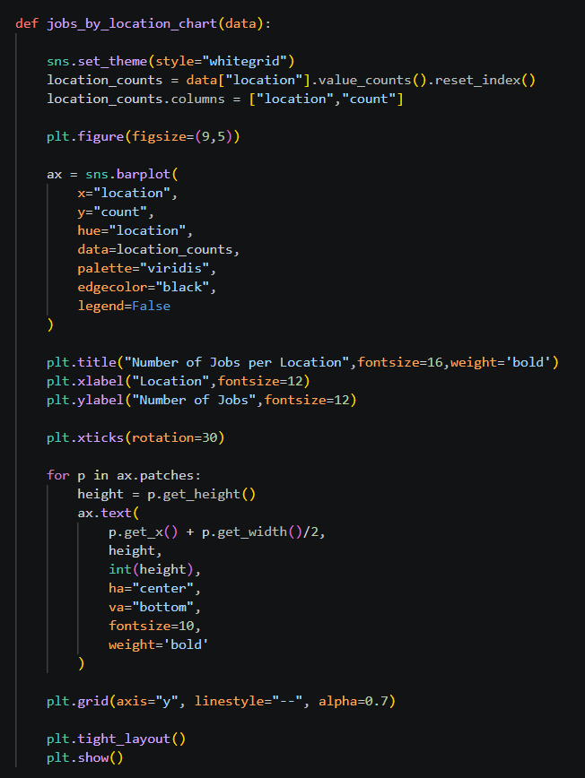
- Histogram (salary distribution)
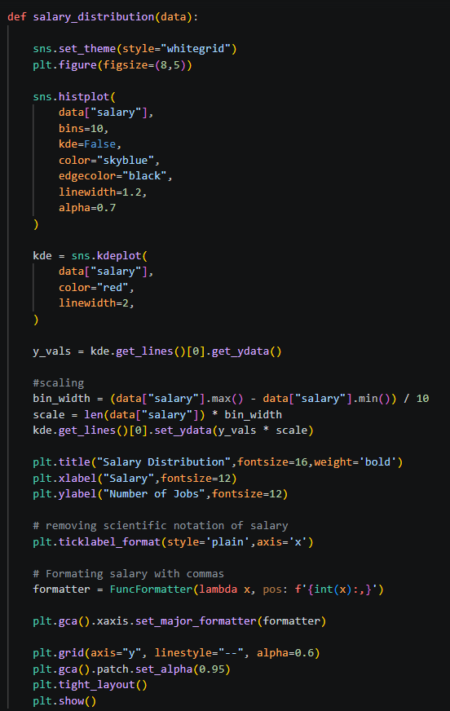
- Pie Chart ( job category )
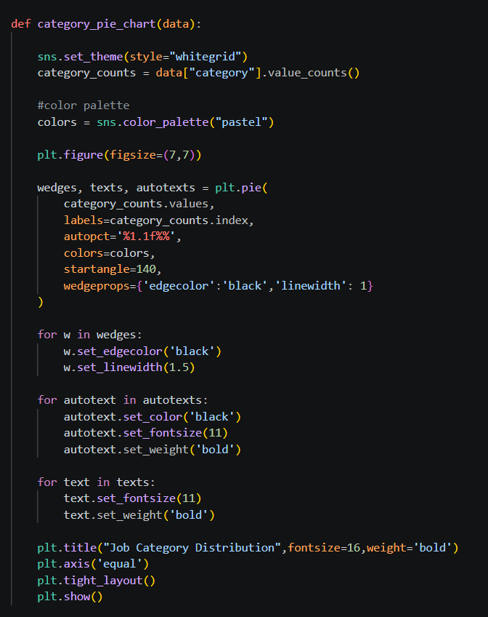
- Scatter plot (experience vs salary)
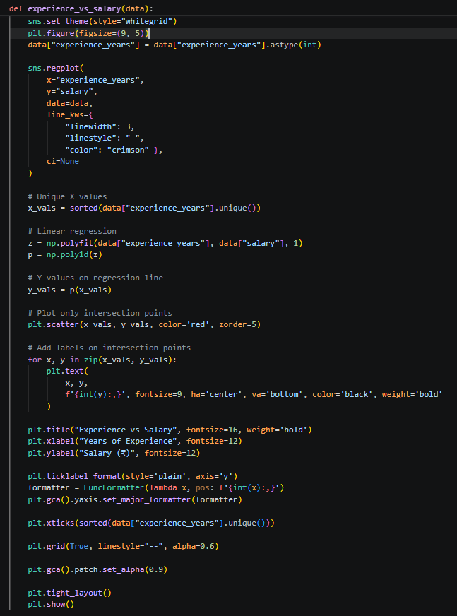
- Line charts (jobs per month)
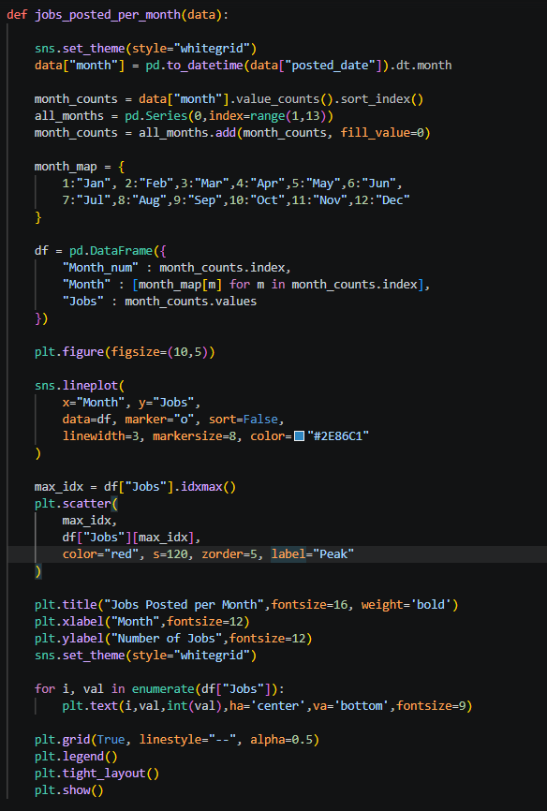

#job_dataset.csv
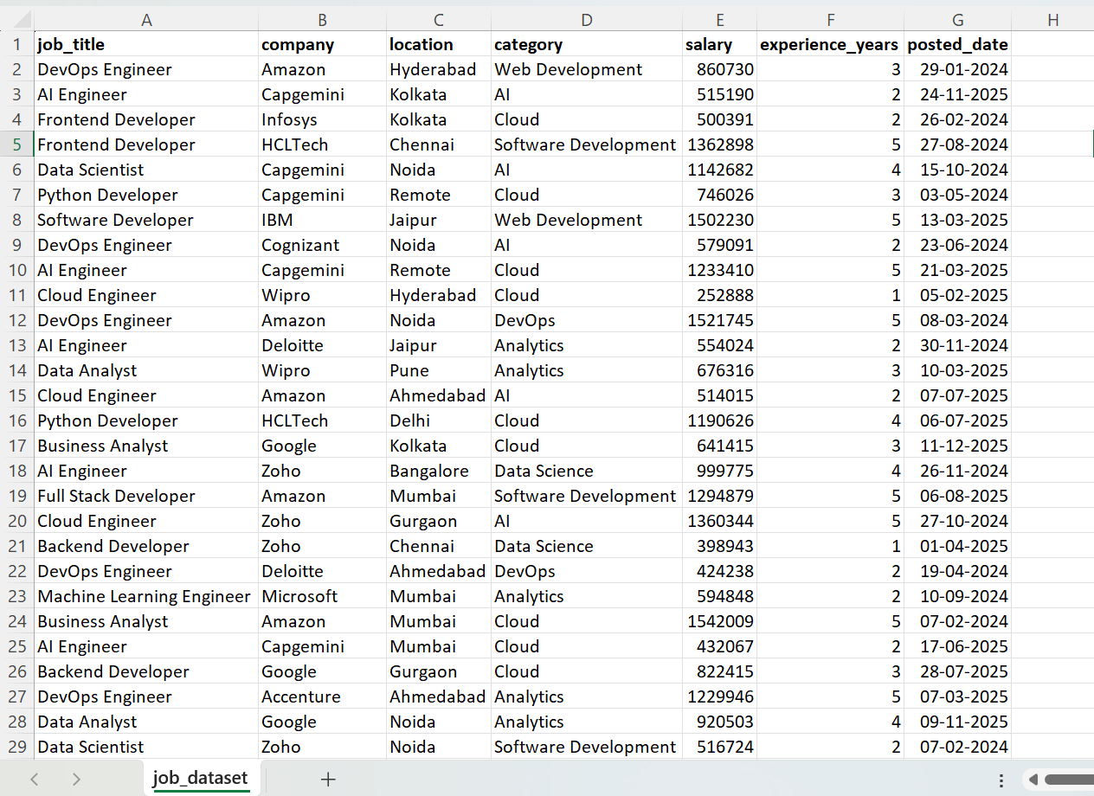
Sample Outputs (CLI)

#Command-Line Interface
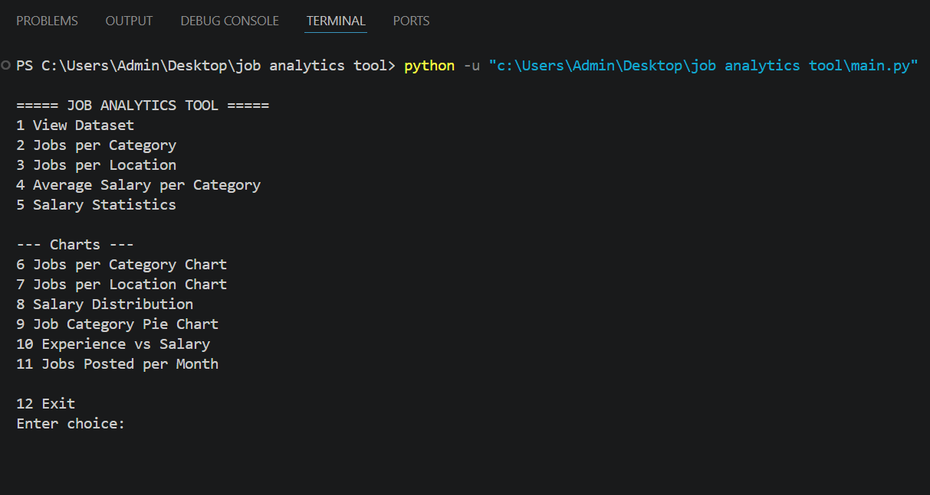

# Sample Inputs and Outputs
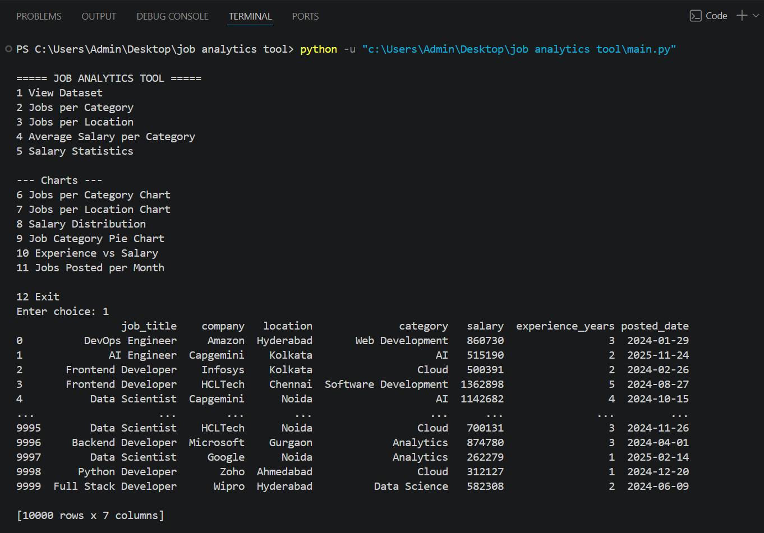
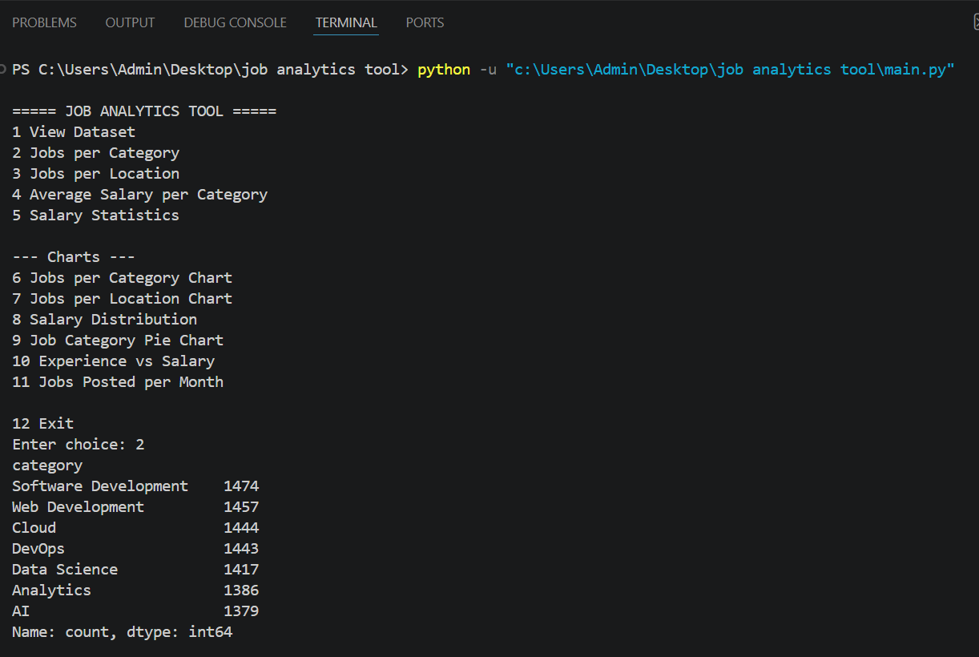
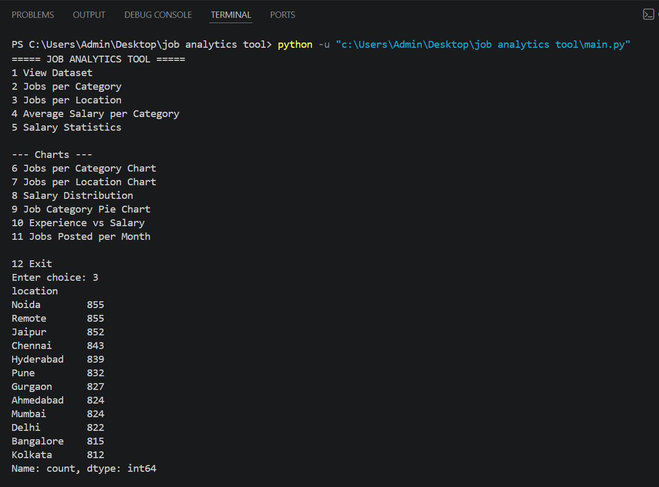
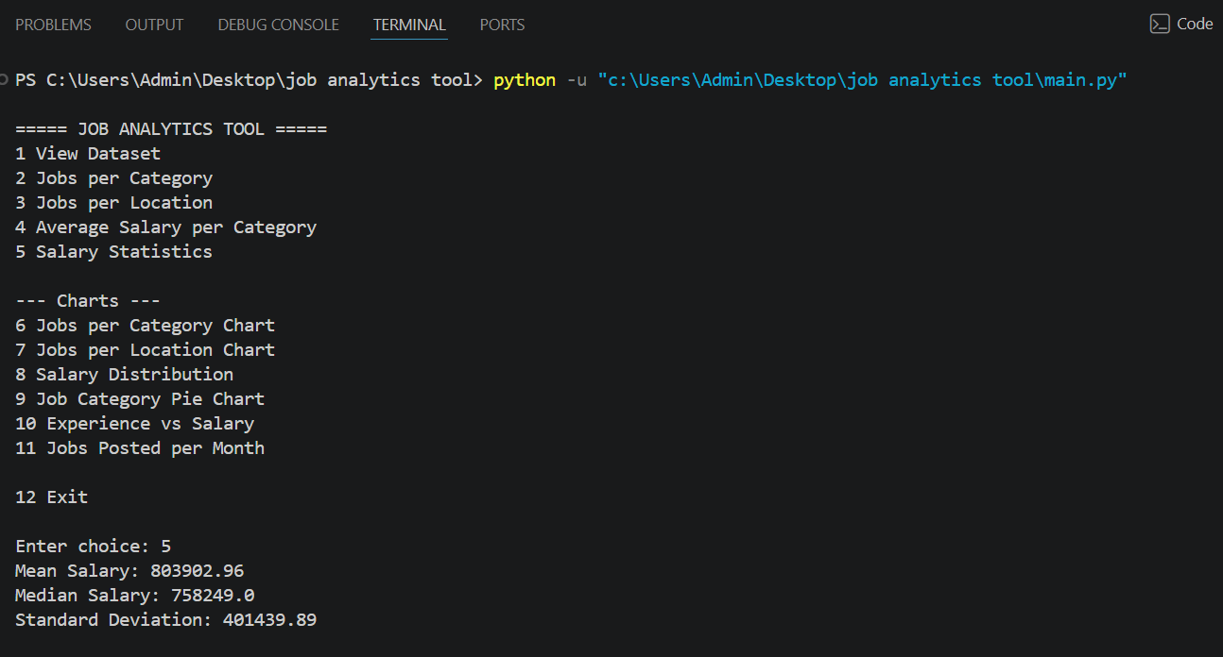
Visualizations and Description

🔸 1. Salary Distribution (Histogram)
- Shows distribution of salary ranges
- Includes KDE curve (trend line)
- Helps identify high/low salary clusters
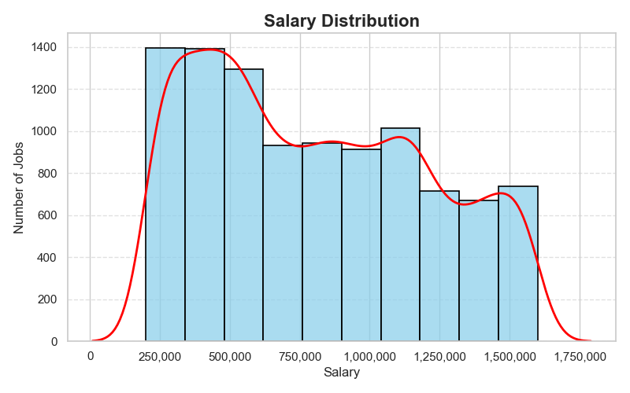

🔸 2. Jobs per Category (Bar Chart)
- Displays number of jobs in each category
- Helps identify most demanding job roles
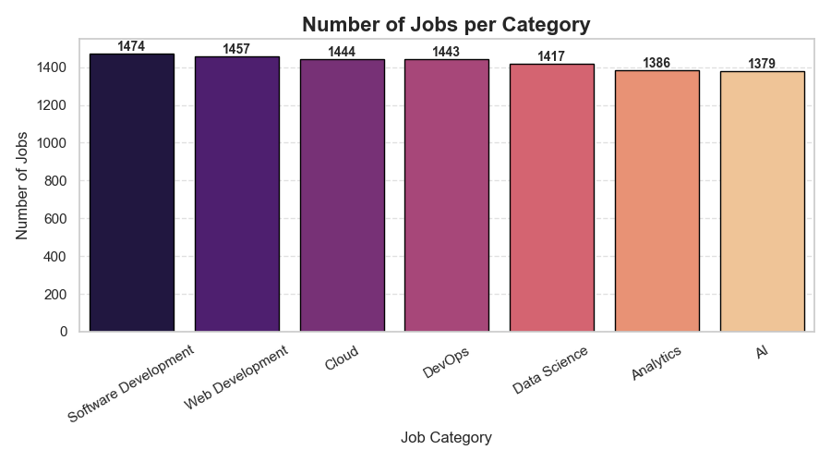
🔸 3. Jobs per Location (Bar Chart)
- Shows location-wise job availability
- Useful for geographical analysis
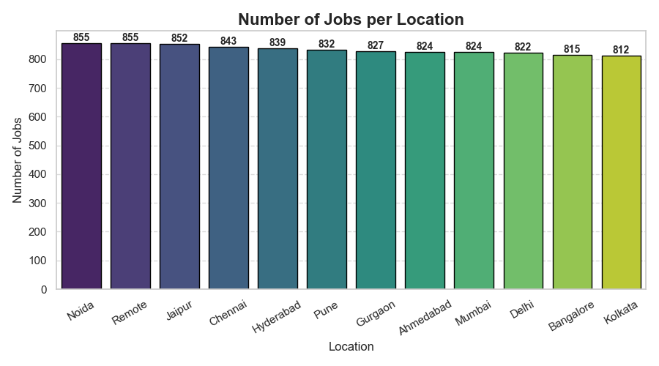

🔸 4. Jobs Posted per Month (Line Chart)
- Shows hiring trends over time
- Detects seasonal hiring patterns
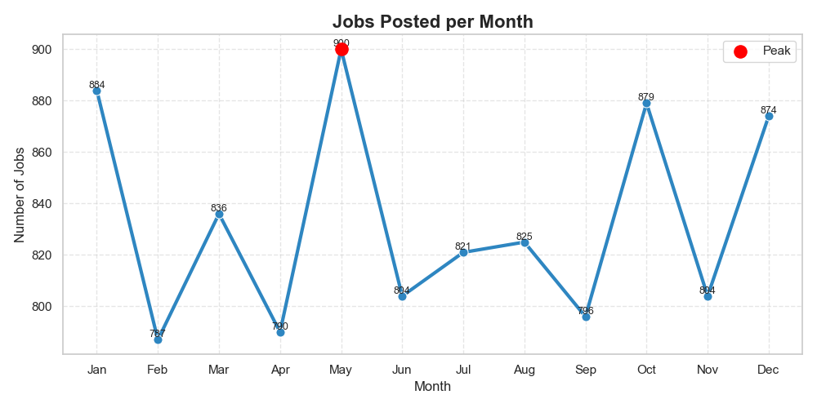

🔸 5. Job Category Distribution (Line Chart)
- Shows Distribution in category
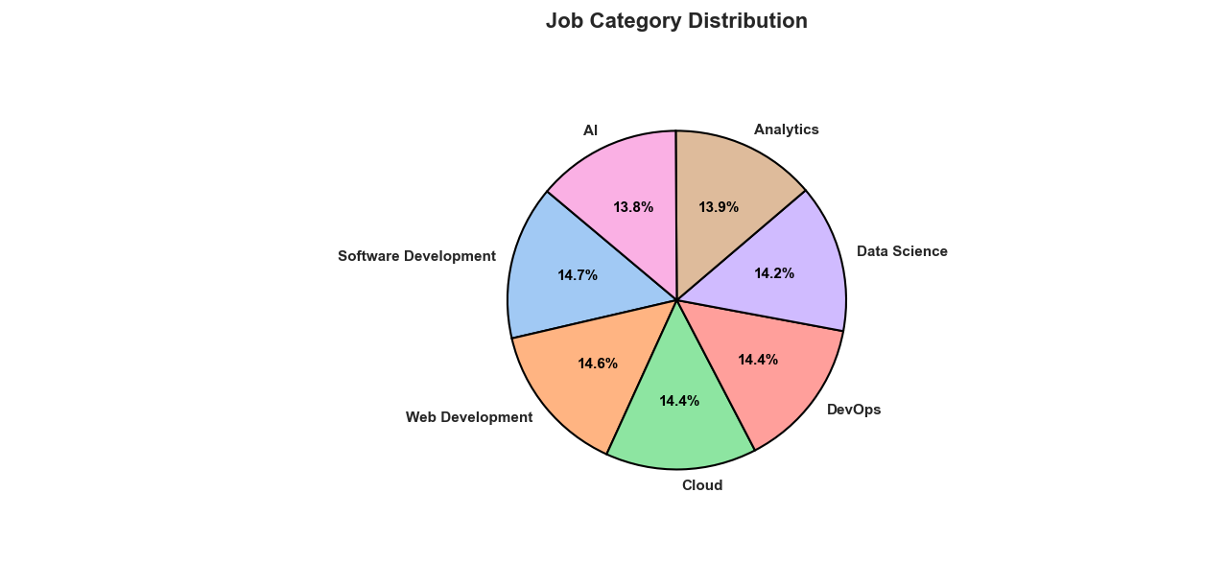
- Detects the no. of jobs per category in Percentage

🔸 6. Experience vs Salary
- Shows relationship between experience and salary
- Includes regression trend line
- Helps understand salary growth
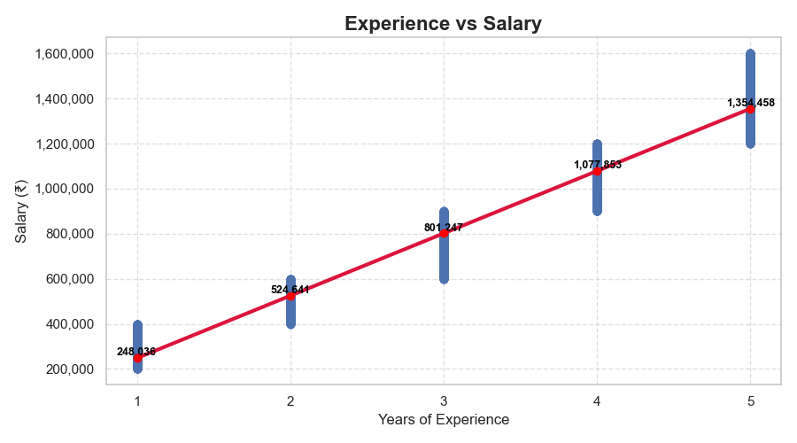
Learning Outcomes

1. Understanding Real-World Data Handling
Through this project, I learned how to work with real-world datasets that are often messy, incomplete, and inconsistent.
Using the Pandas library, I performed tasks such as:
- Loading datasets from CSV/Excel files
- Handling missing values using techniques like fillna() and dropna()
- Removing duplicate records
- Converting data types (e.g., string to integer or datetime)
This improved my ability to clean and prepare raw data, which is one of the most important steps in any data analysis process.

2. Data Preprocessing and Feature Engineering
I understood the importance of preprocessing data before analysis.
In this project, I:
- Extracted useful information (e.g., month from date column)
- Converted salary values into numerical format
- Created new columns for better analysis
This helped me learn how to transform raw data into meaningful structured data, which improves the accuracy of insights.

3. Performing Statistical Analysis
The project enhanced my understanding of basic statistical concepts such as:
- Mean (average salary)
- Median (middle value)
- Standard deviation (spread of data)
- Percentiles
Using NumPy and Pandas, I implemented these calculations and learned how statistics help in:
- Understanding trends
- Identifying outliers
- Comparing different job categories
4. Data Visualization Skills
One of the major learning outcomes was mastering data visualization using:
- Matplotlib
- Seaborn
I created different types of charts, such as:
- Bar charts (jobs per category/location)
- Line charts (jobs per month trends)
- Histograms (salary distribution)
- Scatter plots (experience vs salary)
I also learned how to:
- Customize charts (colors, labels, titles)
- Add annotations and data labels
- Improve readability and aesthetics
This helped me understand how to present data visually for better decision-making.

5. CLI-Based Application Development
I gained experience in building a Command-Line Interface (CLI) application where:
- Users can select options from a menu
- Different functionalities are executed based on input
This improved my understanding of:
- Program flow control
- User interaction handling
- Modular programming

6. Handling Real Errors and Debugging
While working on this project, I encountered several issues such as:
- Visualization errors
- Incorrect scaling of graphs
- Future Warnings in Seaborn
By resolving these, I improved my:
- Debugging skills
- Problem-solving ability
- Understanding of library behavior
7. Improving Data Presentation Skills
learned how to:
- Present results in a structured format
- Add proper titles, labels, and legends
- Make charts visually appealing
This is important for communicating findings effectively to users or stakeholders.

8. Real-World Application Understanding
This project gave me practical exposure to:
- How data analytics tools are built
- How companies analyze job data
- How insights are generated for decision-making
It helped bridge the gap between theoretical knowledge and practical implementation.

Conclusion

The Job Analytics Tool successfully demonstrates the complete workflow of a real-world data analytics system, starting from raw data processing to meaningful insight generation through visualization.
This project highlights the importance of data-driven decision-making by transforming unstructured job listing data into clear and interpretable information. By applying data preprocessing techniques, statistical analysis, and visualization methods, the system enables users to understand trends such as salary distribution, job demand across categories, and the relationship between experience and salary.

Achievement of Project Objectives
The main objectives of the project were successfully achieved:
- Efficient loading and cleaning of job datasets
- Implementation of data preprocessing techniques
- Performing statistical analysis to extract meaningful insights
- Visualizing data using various charts for better understanding
- Providing a user-friendly CLI interface for interaction
The project ensures that users can easily explore and analyze job-related data without needing advanced technical knowledge.

Practical Knowledge Gained
Through the development of this project, strong practical knowledge was gained in:
- Data manipulation and transformation using Pandas
- Statistical analysis using NumPy
- Data visualization using Matplotlib and Seaborn
- Writing modular and structured Python code
- Building interactive CLI-based applications
Additionally, handling real-world issues such as missing values, incorrect formats, and visualization scaling improved problem-solving and debugging skills.

Impact and Importance
This project demonstrates how data analytics can be used to:
- Identify trends in job markets, Analyze salary patterns
- Understand demand for different job roles, Support better decision-making
Such tools are widely used in industries for workforce planning, recruitment strategies, and market analysis.

